SlugPath

**Sprint 2 Report**

Team Slugstras

Release Name: SlugPath Beta

Release Date: 03/22/18

Revision 1.1 (2/21/18)

**Actions to stop doing:**

None, everyone is working together and communicating very well.

**Actions to start doing:**

Team should power through remaining data collection to end up with a fully functional demo of a high definition map containing every path to get around campus.

**Actions to keep doing:**

Communicating. Promptly responding to messages and updating why they may be late to a discussion/scrum meeting.

Meeting every MWF for scrum meetings.

Clarify on tasks being done when not clear.

Discuss what others are doing.

Peer-coding when code is not clear to follow.

**Work completed/not completed:**

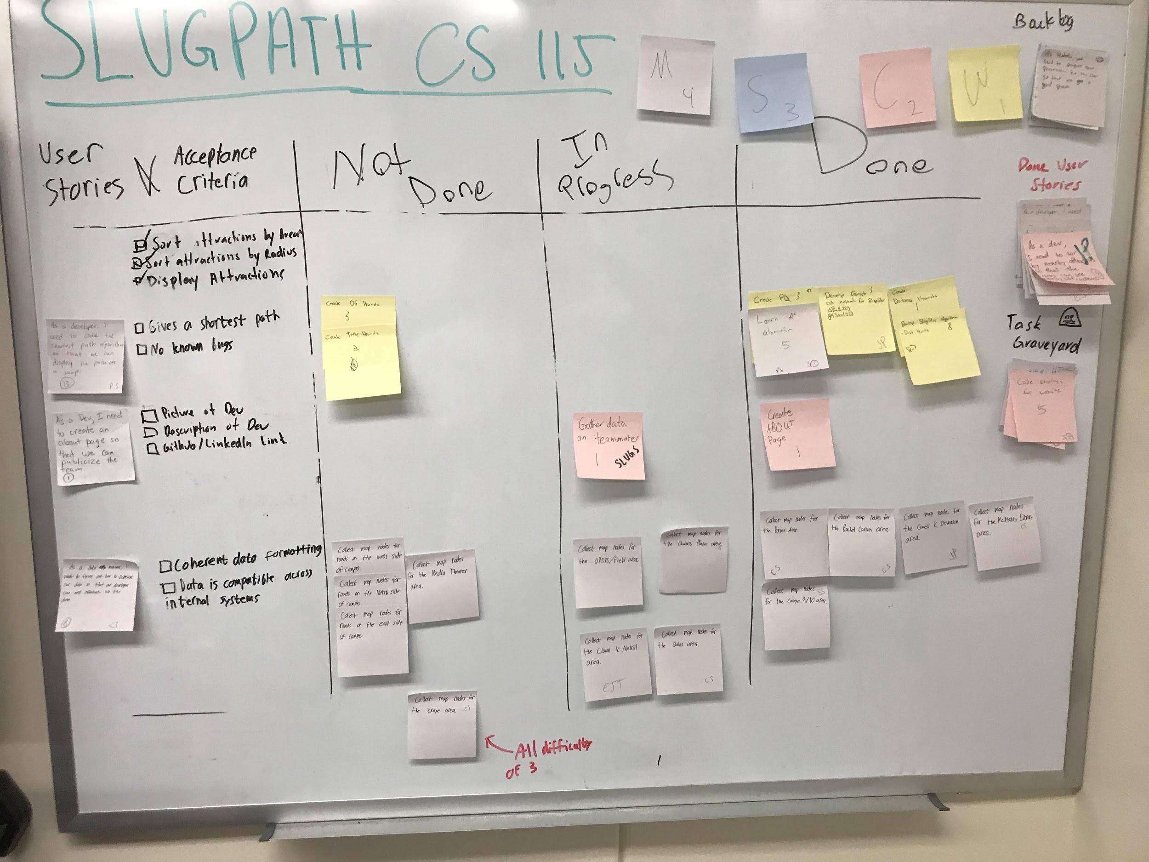

* User Story 1: As a javascript developer, I need to develop the shortest path algorithm so that we can display the shortest path on a visualized map.

User Story 1 Tasks

1. Create difficulty, time, and distance heuristics -Completed-
2. Create priority queue and graph objects -Completed-
3. Implement algorithm -Completed-

* User Story 2: As a data manager, I want to figure out how to represent our data so that our developers can effectively use the data.

User Story 2 Tasks

1. Create map nodes for each big node location -In Progress-

* User Story 3: As a developer, I need to sort by nearby attractions so that the users can see nearby attractions.

User Story 3 Tasks

1. Implement sort by area and display by area -Completed-
2. Implement sort by proximity and display by proximity -Completed-

* User Story 4: As a dev, I need to create an about page so that we can publicize the team.

User Story 4 Tasks

1. Gather data from team members -Completed-
2. Implement about page on website -Completed-

**Work completion rate:**

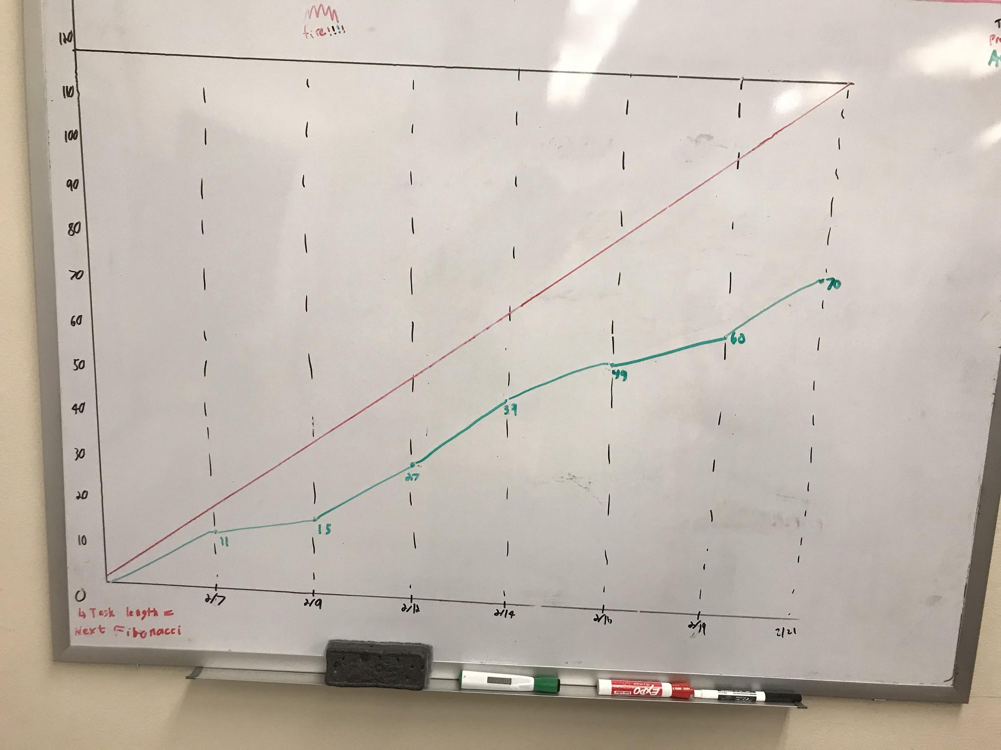

User stories completed 3.

Total number of ideal work hours: 120 hours

Actual number of hours worked: 70 hours

Total number of days in Sprint 2: 21